JUnit Testing Exercises

**Exercise 1: Setting Up JUnit**

Scenario:

You need to set up JUnit in your Java project to start writing unit tests

**CODE SOLUTION**

**Main.java**

import org.junit.jupiter.api.Test;

import static org.junit.jupiter.api.Assertions.assertEquals;

public class Main {

@Test

void testAddition() {

assertEquals(4, 2 + 2);

}

}

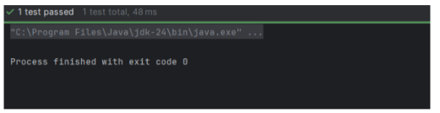

**Exercise 3: Assertions in JUnit**

Scenario: You need to use different assertions in JUnit to validate your test results.

**Code Solution**

AssertionsTest.java

import org.junit.Test;

import static org.junit.Assert.*;

public class AssertionsTest {

@Test

public void testAssertions() {

assertEquals(5, 2 + 3);

assertTrue(5 > 3);

assertFalse(5 < 3);

assertNull(null);

assertNotNull(new Object());

}

}

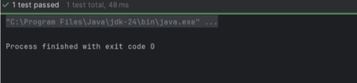

Exercise 4: Arrange-Act-Assert (AAA) Pattern, Test Fixtures, Setup and Teardown Methods in JUnit

CalculatorTest.java  
import org.junit.*;

import static org.junit.Assert.*;

public class CalculatorTest {

private Calculator calculator;

@Before

public void setUp() {

calculator = new Calculator();

System.out.println("Setup before test");

}

@After

public void tearDown() {

calculator = null;

System.out.println("Teardown after test");

}

@BeforeClass

public static void initAll() {

System.out.println("Global setup (runs once)");

}

@AfterClass

public static void tearDownAll() {

System.out.println("Global teardown (runs once)");

}

@Test

public void testAddition() {

int a = 5;

int b = 3;

int result = calculator.add(a, b);

assertEquals(8, result);

}

@Test

public void testSubtraction() {

int a = 10;

int b = 4;

int result = calculator.subtract(a, b);

assertEquals(6, result);

}

}

class Calculator {

public int add(int a, int b) {

return a + b;

}

public int subtract(int a, int b) {

return a - b;

}

}

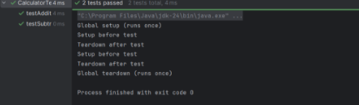

## ****Exercise 1: Mocking and Stubbing****

import org.junit.jupiter.api.Test;

import static org.junit.jupiter.api.Assertions.*;

import static org.mockito.Mockito.*;

interface ExternalApi {

String getData();

}

class MyService {

private final ExternalApi api;

public MyService(ExternalApi api) {

this.api = api;

}

public String fetchData() {

return api.getData();

}

}

public class MockitoTest {

@Test

public void testExternalApi() {

ExternalApi mockApi = mock(ExternalApi.class);

when(mockApi.getData()).thenReturn("Mock Data");

MyService service = new MyService(mockApi);

String result = service.fetchData();

assertEquals("Mock Data", result);

System.out.println("Test passed! Result: " + result);

}

}

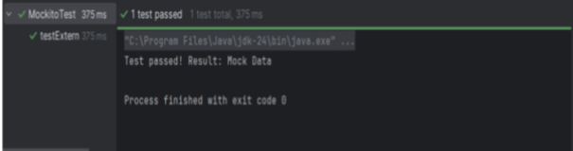

**Exercise 2: Verifying Interactions**

import org.junit.jupiter.api.Test;

import org.mockito.InOrder;

import static org.mockito.Mockito.*;

interface Dependency {

void start();

void process();

void end();

}

class OrderDependentService {

private final Dependency dependency;

public OrderDependentService(Dependency dependency) {

this.dependency = dependency;

}

public void executeProcess() {

dependency.start();

dependency.process();

dependency.end();

}

}

public class InteractionOrderTest {

@Test

public void testMethodCallOrder() {

Dependency mockDependency = mock(Dependency.class);

OrderDependentService service = new OrderDependentService(mockDependency);

service.executeProcess();

InOrder inOrder = inOrder(mockDependency);

inOrder.verify(mockDependency).start();

inOrder.verify(mockDependency).process();

inOrder.verify(mockDependency).end();

System.out.println("Test passed: Methods called in correct order!");

}

}

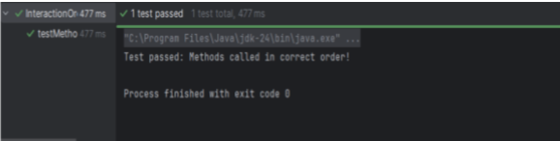

**Exercise 3: Logging Error Messages and Warning Levels**

import org.slf4j.Logger;

import org.slf4j.LoggerFactory;

public class LoggingExample {

private static final Logger logger = LoggerFactory.getLogger(LoggingExample.class);

public static void main(String[] args) {

logger.error("This is an ERROR message - something went wrong!");

logger.warn("This is a WARNING message - potential issue detected");

logger.info("This is an INFO message - normal operation");

logger.debug("This is a DEBUG message - detailed information");

int userId = 42;

logger.info("User with ID {} logged in", userId);

}

}

